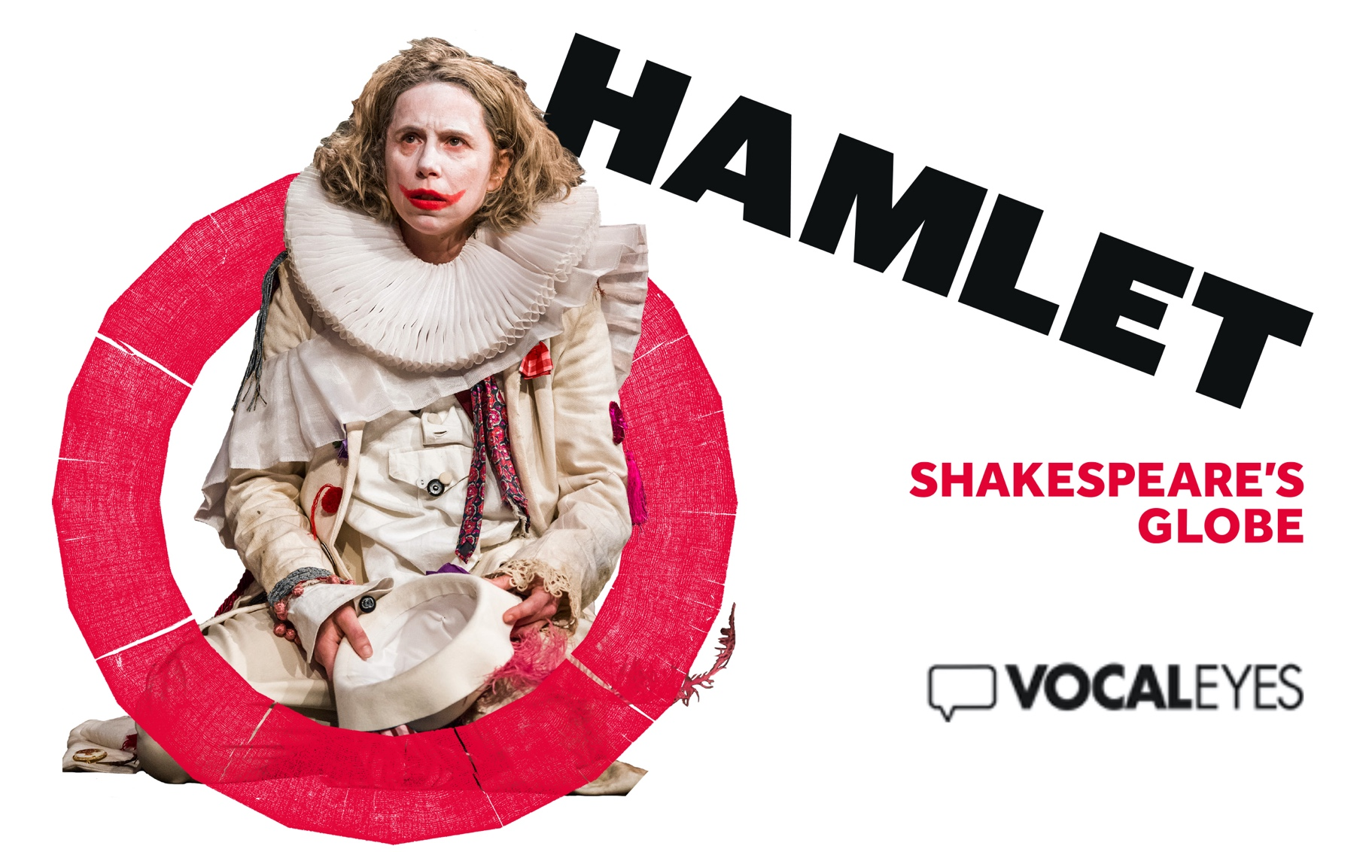

INTRODUCTORY NOTES
Welcome to this introduction to Hamlet by William Shakespeare, directed by Federay Holmes and Elle While for Shakespeare’s Globe. These introductory notes were written by Lonny Evans and Jenny Stewart- Cosgrove, and script edited by Louise Fryer.
The Globe theatre is a faithful reconstruction of the open-air theatre built in 1599, where many of Shakespeare’s greatest plays were first performed.
It has been constructed using as many Elizabethan building methods as possible. Opened officially in 1997, today’s Globe is a twenty-sided wooden structure made of oak and lime plaster – with the first thatched roof permitted in London since the Great Fire in 1666.
In the centre of the building is a space called the Yard, where people are permitted to stand – the Groundling area. Other members of the audience sit on wooden benches in one of the three galleries, which run around
the circular auditorium – the upper gallery being some ten metres above the yard. The theatre is open to the elements and performances continue whatever the weather – even during a thunderstorm.
Thrusting out into the Yard is the large rectangular stage. This stands at shoulder height – so that the groundlings nearest to the stage can lean against it, and actors can stoop down to address members of the audience directly, face to face.

Towards the front of the stage are two huge pillars, one on either side. Each pillar has been created from a complete oak tree. Although made of wood these pillars are ingeniously painted to look like polished marble. The deep base of each is octagonal and the column above is topped with an ornately carved Corinthian capital, gilded with real gold. The pillars
support an overhanging roof – called the ‘heavens’. Its underside is divided into panels by gilded wooden ribs. Each panel is painted deep blue and decorated with stars, moons or signs of the zodiac.
The back wall is two stories high with a wood panelled minstrel’s gallery on the upper level. The middle of the gallery thrusts out four metres above the stage and is supported by pillars on the front two corners. There are three entrances at the rear of the stage – the main entrance has double doors and is directly under the minstrel’s gallery the two side entrances are on the far left and right and are large wooden doors.

At one point in the action a trap door is opened in the stage floor creating an oblong space that two people can comfortably stand in up to their thighs.
Shakespeare’s Globe’s website sums up the story of Hamlet as follows: ‘Learning of his father’s death, Prince Hamlet comes home to find his uncle married to his mother and installed on the Danish throne. At night, the ghost of the old king demands that Hamlet avenge his ‘foul and most unnatural murder’. Encompassing political intrigue and sexual obsession, philosophical reflection and violent action, tragic depth and wild humour, Hamlet is a colossus in the story of the English language and the fullest expression of Shakespeare’s genius.’

There are twelve actors in the mixed heritage ensemble, six men and six women – some of whom play up to three different roles. There is an element of cross casting with female actors taking male roles and visa versa. When this occurs, they wear the clothes expected of their character’s sex at this period of history, so men are in dresses, with women in doublet and hose or trousers.

In the programme E.M. Parry, the designer writes: ‘We’ve definitely drawn on the practices of early Modern theatre in our design choices. Elizabethan theatre companies embraced a kind of playful and expedient anachronistic eclecticism in their visual worlds. Within a single play, audiences would have seen a cheerful mash up of objects and clothing recycled from earlier productions (…)’.

The role of Guildenstern is played by deaf actress Nadia Nadarajah who uses British Sign Language to communicate the text. In the programme she explains that: ‘The translation process was extremely challenging because Shakespearean language cannot be translated literally. We had to discuss the meaning and intent of each line before we could decide on a sign equivalent.’
Hamlet, the Prince of Denmark is played by a petite woman in her thirties with short blonde curly hair. When we first meet Hamlet, he is moping around and dragging his heels like a teenage goth in tight black trousers, black trainer boots, a black beanie hat and a black hooded raincoat which is gathered at the waist. As the story unfolds Hamlet appears in a more excitable mood wearing a white clown outfit, his gestures playful one minute, frantic the next. He wears a classic clown white face, his lips painted with a garish, red, upturned smile. The outfit consists of white pantaloons and shirt under a long white jacket with a dangling scarlet

tassled belt. The jacket has icons embroidered on it, including a row of noughts and crosses on the front and a red sequined heart embroidered on the left sleeve. He wears two white ruffs, one at his throat and one worn like a sash that flaps in the breeze as he skips about. On his feet, black
spotty socks and white trainer boots. On his head a white felt hat decorated with a large purple flower, a blue and grey necktie tied as a hatband and a long red feather.
His mother, Gertrude is an older woman with short silver spikey hair under a black and pearl headpiece. She wears a long burgundy and gold dress with a narrow bodice and a farthingale underneath it which makes it stick out stiffly at the hips. There are ruffles at the waist and a lace trimmed collar around the square neckline. Gertrude behaves politely in company, her posture composed, her hands clasped in front of her. Later, surprised in her boudoir in just a nude coloured nightgown and a pale blue dressing gown she becomes more expansive and expressive.

She is married to Hamlet’s Uncle, Claudius a tall, thickset older man with short greying hair swept back from his face. Claudius has the bearing of a strong, powerful leader who is under control, but his very expressive face often betrays his true emotions. At times his bushy eyebrows shoot up and a look of pure astonishment or incredulity comes over him. He dresses grandly in burgundy breeches and matching waistcoat with a black ruff at the throat and a billowing gold brocade cloak trimmed in dark brown fur. His fancy black shoes are heeled and adorned with gold and he wears a heavy gold pendant.

Horatio is Hamlet’s loyal confidant and friend. He is played by a slender woman with a piercing gaze and her fair hair swept back in a tight French plait. When we first meet Horatio, he strides confidently about in brown shoes, black trousers and a cream roll neck under a black duffle coat. He wears a grey and gold striped college scarf around his neck. Horatio is watchful, often standing back from the action, observing his friend Hamlet, ready to jump in when needed.

Marcellus is a courtier in his twenties who keeps the watch with Hamlet and Horatio as they await the appearance of the ghost. Played by a woman,
he is dressed in black trousers tucked into black boots and topped with a long black waistcoat that hangs to the hip. Marcellus is light on his feet
despite his heavy-set physique. He wears an earnest expression, his brow furrowed, and lips pressed together. His long black hair is braided and tied await from his face. He carries a long spear. With him is a Guard. A tall man in his fifties with a wild grey beard. He shuffles in, wearing baggy grey trousers tucked into boots and a brown leather chest plate, a tin helmet is jammed on his head, a sword in his hand.

The Ghost is a solid, burly older man with a big, bushy grey brown beard. He has a rather lumbering presence with nothing ethereal about it. He’s dressed as if preparing for battle with only half his armour on. He wears brown trousers tucked into brown boots and a brown cloth top. Over this he wears bits and pieces of armour, a single metal elbow protector, a silver gauntlet, tucked into his belt and a burnished helmet on his head with the visor worn up.

Polonius is a trusted, senior member of the court. He is spindly man in his late fifties, so tall that he appears to stoop. He is dressed in muted grey doublet and hose, grey stockings and flat black shoes. Over this he wears

a long cloak in a paler grey with fur trim at the hem and sleeves. Around his neck is stiff grey ruff. Polonius has a long serious face with deep set brown eyes that regard others attentively from behind round wire frame glasses, another pair of glasses hangs around his neck on a black silk thread - he puts these on to read, holding the others between finger and thumb as he does. He has a full beard, neatly trimmed and in the most part jet black although there is a shock of white hair on his chin. His head is covered
with a black floppy velvet cap.
Leaertes is the son of Polonius. Played by a woman he is a young man, barely in his twenties. He is short in stature and petite in frame but moves with a dynamic spitfire quality that demonstrates a confidence in who he is. Laertes’ pale face with blue eyes and small nose is framed by vibrant ginger hair that is cut short and combed back from his forehead. Like his father his doublet and hose are pale grey although his doublet is worn undone with a navy-blue hoodie underneath it. He wears calf high black boots with a buckle on the side. Later he discards the grey and changes to a black ensemble.

Ophelia is Leaertes’ sister. Played by a man, Ophelia is a young, innocent woman in her late teens. Tall and slim she towers over her short brother as she hugs him affectionately, ruffling his hair. Her dress is pale cream cotton with a tight stiff bodice that buttons at the back and finishes in a sharp V shape at her waist. From here it flares out in a hooped skirt that touches the floor. The sleeves of the dress are long and finish at each wrist with a frilled white cuff. Ophelia has fine features, with clear smooth skin and large dark eyes. Her hair is cut very short and combed into a soft side parting that touches her right eyebrow. She stands very straight and upright, small hands clasped together. Later Ophelia appears in a plain black shift dress. It has t-shirt sleeves and a scooped neck. It hangs straight down to her calf, and she has a pair of flat black slip on shoes.

Rosencrantz and Guildenstern are two student friends of Hamlet. Rosencrantz is the older of the two. Tall and slim with shoulder length, bushy grey hair and a full beard. He has a puzzled expression often twitching his lips and shifting the gaze of his pale blue eyes from person to person as though searching for the answer. to His clothes are bright red corduroy trousers tucked into black boots. He teams these with a peach shirt and a pink waistcoat with brass buttons up the front. When he first arrives, he wears a dark maroon raincoat with a matching woollen hat pulled down low on his head. A blue canvas backpack is slung across his shoulders.

Guildenstern, played by a woman, is about two foot shorter than his friend and dressed head to toe in shades of yellow and brown. Tan breeches are worn with knee-high brown leather boots and teamed on top with a fawn shirt and a silk, butterscotch waistcoat. Guildenstern’s face is expressive and flits between emotions with ease; an easy grin, a wide eyes surprise, a confused frown. When we first meet him, he wears a mustard yellow, rain proof poncho with a hood. His dark hair tied away from his face in a small ponytail.

A group of Players visit the court. There are four of them, two men and two women. They are all in modern dress. Jeans, hoodies, jogging bottoms and trainers. They carry suitcases and instrument cases with them. The leader of the group is a tall, handsome young man dressed in black jeans and a bright red jumper. His floppy brown hair is casually combed and his brown eyes alert and watchful. He commands the space with confidence as he performs.

We also meet Reynaldo, Fortinbras and a Grave Digger. Reynaldo is an attentive courtier dressed in a long green, fur trimmed coat over black trousers tucked into boots.
Fortinbras and his men arrive with a flourish all dressed in black. Long black trousers and long-sleeved polo neck sweaters with black, leather plating worn on their shoulders and sleeves. They wield swords and swagger, looking down their noses at their surroundings. Two of the men wear floor length black leather coats and woollen beanie hats.
The Grave Digger is in his sixties. He is slow and methodical in his work. His off-white shirt and grey trousers are grubby from the soil that he digs, and his hands are protected by brown woolen fingerless gloves. He wears a yellow, high-vis waistcoat and worn black boots. His soft face has bushy eyebrows, blue eyes and his thin lips are swathed with a wild, straggly beard.

CAST AND PRODUCTION CREDITS

The Globe Ensemble are:
Catrin Aaron who plays Horatio
James Garnon who plays Claudius
Colin Hurley who plays the Ghost, a Grave Digger and a Player
Bettrys Jones who plays Laertes and a Player Richard Katz who plays Polonius and a Priest Jack Laskey who plays a Player and Fortinbras Pearce Quigley who plays Rosencrantz
Nadia Nadarajah plays Guildenstern Shubham Saraf who plays Ophelia Helen Schlesinger who plays Gertrude Michelle Terry who plays Hamlet
Tanika Yearwood who plays Marcellus, Reynaldo and a Player
The Musical Director and on Trumpet is Adrian Woodward
Louise Anna Duggan, percussion
Hilary Belsey and Stephanie Dyer play Trombone
Adam Crighton plays the Bass Trombone
The Choreographer is Sian Williams The Composer is James Maloney The Designer is E.M. Parry
And the Directors are Federay Holmes and Elle While

To contact VocalEyes, please email us on

enquiries@vocaleyes.co.uk or visit vocaleyes.co.uk

