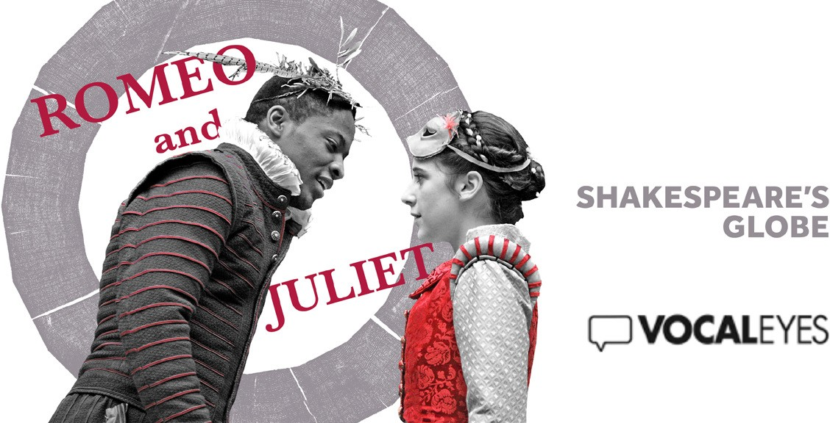

INTRODUCTORY NOTES
Welcome to this introduction to Romeo and Juliet by William Shakespeare. It’s been directed for Shakespeare’s Globe by Dominic Dromgoole. These introductory notes were written by Joanna Myers and Willie Elliott, and script edited by Clare Le May.
The Globe Theatre is a faithful reconstruction of the open- air theatre built in 1599, where many of Shakespeare’s greatest plays were first performed. It’s situated across the river from St Paul’s Cathedral – on the south bank of the Thames, about 170 metres from the site of the original and has been constructed using as many Elizabethan building methods as possible. Opened officially in 1997, today’s Globe is a twenty-sided wooden structure made of oak and lime-plaster – with the first thatched roof permitted in London since the Great Fire in 1666.
In the centre of the building is a space called the Yard, where there are about 600 standing, or Groundling, places. Other members of the audience sit on wooden benches in one of the three galleries, which run around the circular auditorium – the upper gallery being some ten metres above the yard.

Thrusting out into the Yard is the large rectangular stage. This stands at shoulder height – so that the groundlings nearest to the stage can lean against it, and actors can stoop down to address members of the audience directly, face to face. For this production, the stage has been extended out by about another two metres. The actors sometimes enter through the yard, moving amongst the groundlings, before mounting steps on either side, onto the stage.
Towards the front of the stage are two huge pillars, one on either side. Each pillar has been created from a complete oak tree. Although made of wood they are ingeniously painted to look like polished marble. The
deep base of each is octagonal and the column above is topped with an ornately carved Corinthian capital, gilded with real gold. The pillars support an overhanging roof – called the ‘heavens’. Its underside is divided into panels by gilded wooden ribs. Each panel is painted deep blue and decorated with stars, moons and signs of the zodiac.
The back wall of the stage is two stories high with a minstrel’s gallery on the upper level. From the centre of the stage a simple wrought iron spiral staircase ascends towards the ‘heavens’ – to the upper gallery. A plain wrought iron balcony runs along its front and sides. Behind the spiral staircase, at stage level, a central archway leads to an unseen back room – the Tiring House – or backstage area. At times, double doors with two brass rings block off this entrance. On either side, at shoulder height, two small arched recesses about 30cm high have been cut into the wall. In each stands a simple wooden cross.
Two more open arched entrances stand to the far left and right, with a passageway beyond. Characters pass along this passageway, loiter or observe the action on stage. Above the archway on the left hangs a painted icon of the Virgin and child. The wall and archways
are painted deep ochre, which often seems to glow, as though lit from candlelight.

There’s a trap door on the stage, which creates a lower level. There is much movement in this production between these levels, representing the characters’ changing fortunes.
The action of the play takes place in various locations in Verona, in Italy. We move from the streets to a grand house, a high balcony, a monastery and a crypt. The story moves swiftly from place to place with little break in the dialogue. Scenes are changed by the townsfolk and serving men moving simple furniture and props.
For instance when we’re in a bustling Verona street market, the right archway becomes a game stall - hung with hams and pheasants. Women in rustic attire and mobcaps sit by their wares, displayed in wicker baskets and trays on either side of the stage, selling a tempting array of produce – whole cheeses, pumpkins, cauliflowers and apples, and flagons of ale.
The characters wear traditional Elizabethan costume of the late 16th century, in colours reminiscent of Renaissance Italian paintings. The ordinary Verona folk are dressed in an assortment of soft rustic colours – rusts, teal blue, cream and mauves, open necked shirts, jerkins, knee-
length breeches and soft caps for the men, with full woollen skirts and long aprons and mob caps for the women.
The city is ruled by two influential and opposing houses, who each wear their own signature colours; the Montagues dress predominantly in blues and the Capulets, in reds. The men wear doublet and hose – a fitted jacket with short trousers known as trunk hose, and fitted tights or stockings, and starched ruffs. The younger men don short full flowing capes for the evening, worn slung over one shoulder, leaving the sword arm free.
The women wear stiff richly embroidered boned bodices and full length gathered skirts over a crescent shaped, padded roll or bustle, tied around the waist.

This accentuates the body’s natural curve and enables the gathered fabric to fall heavily in folds behind. When attending an opulent ball, the characters wear an assortment of colourful and imaginative masks or
hats, topped with feathers.
There are 14 main characters, with the multi-racial cast of over 20 playing an assortment of others including Citizens, serving men and monks. There’s also a male quartet.
Three of these become the chorus, who collectively act as a narrator. And there are five musicians, who play an assortment of Elizabethan instruments.
From the house of Montague – Romeo is a tall handsome Afro Caribbean youth in his late teens whose black hair is cut close to his head. He gestures expansively as he speaks, striding gracefully around the space, his eyes lifted to Heaven. When we first meet him his white shirt is open at the collar and his breeches are deep blue, the colour of the Montague family, with the addition of an orange pinstripe. Later Romeo dons a matching doublet, buttoning it up, but leaving the collar undone to expose his neck. Later still he changes into a golden doublet with red velvet sleeves. His golden breeches have red velvet lining. When masked for a ball Romeo becomes a ‘Green Man’, his mask made of twigs and leaves.
Romeo’s friend Mercutio, a Caucasian, is also in his late teens. He has a careless arrogance in his manner and his dress. His green doublet, with green and yellow sleeves, hangs open and his shirt often hangs out of his red breeches. His thick hair stands up like a short brush and his chin has a patchy beard. He has a light-hearted irreverence, and indulges in bawdy humour and innuendo, throwing an arm over his friends’ shoulders. But his humour is suffused with an unpredictable antagonism that seems ready to bubble up at any moment.
Romeo’s other friend Benvolio is tall and thin limbed. His light brown hair is thick and swept into a side parting. He has an angular face with a smooth

complexion, a sharp nose and deep set watchful eyes. He dresses in green doublet, hose and breeches. He is cajoling and enthusiastic, but he has a sensibility that makes him a good leveller for Mercutio’s spiky nature.
Romeo’s parents both wear the Montague royal blue, trimmed with golden embroidery. Lord Montague is in his sixties. His white receding hair is closely cropped and his goatee beard trimmed neatly. His doublet is buttoned to the neck, where a white ruff flourishes. He stands, hands by his side, his chin high, ready to rebuff any onslaught from his enemies.
In her forties, Lady Montague has her black hair pulled back from her round face and pinned back in a bun.
Her floor length dress brushes the ground as she walks. Saying little, the piercing gaze of her steely blue eyes and her fixed jaw communicate all that is required.
The authoritative Prince is a towering figure, well over six foot tall. He’s in his early fifties and powers into the space, to maintain order. He wears a luxurious doublet and hose of silver and black, beneath a matching calf length sleeveless gown, which billows as he walks. His black receding hair is cut short, with his pointed clipped beard resting on a high starched ruff.
Capulet is a distinguished man in his late 50s, of medium build and height, with a full head of silver waves and a clipped beard. He wears a striking burgundy doublet and hose, mauve stockings and burgundy shoes. Over this he wears a knee-length black velvet gathered cape, with deeply slashed sleeves, which fall in strips as he moves. He is a jovial and hospitable host, displaying great energy and authority within his household, yet testy, with a fierce anger when defied.
His wife, Lady Capulet is an attractive woman of middle age and slender build, with a wide forehead, dark eyes and full lips. She’s elegantly attired in a gold and rust tightly bodiced dress, which falls in a small train behind her. The

dress has a white upstanding collar, and full ivory satin sleeves, which stand up at the shoulder, tapering to the wrist. Lady Capulet wears her raven hair high off her face and secured in a bun, decorated with pearls. More pearls adorn her slender neck. She’s vivacious and displays an ambition for a prosperous marriage for her daughter Juliet, although there’s a cool restraint between them, and they seem ill at ease when in each other’s company.
Their daughter Juliet is barely out of her childhood, at just 14 years, a vision of grace and innocence.
Slender and diminutive in stature, she has an alabaster complexion, heart shaped face and wide brown eyes.
Her long dark hair is parted in the middle and drawn off her face, either in a loose bun, or a plait entwined with ribbon, which hangs down her back. She wears a simple pinafore dress in muted teal blue, the bodice laced up the back, over a white cotton chemise with a
lace trim. A short burgundy scarf is tied round her waist. Juliet moves with the grace of a dancer with small light steps. She seems set apart in the midst of opulence and artificiality. She stands in dutiful obedience before her mother, arms loosely by her side, or gazes down from her balcony onto an unknown world with a serenity and gravity that belies her tender years.
In contrast to her restrained relationship with her mother, Juliet is fondled and spoilt by her beloved Nurse and confidante, who demonstrate a warmth and fondness.
Nurse is in her forties, with a wide forehead, her somewhat pallid complexion showing the strains of the hardships of life, her greying blonde hair drawn off her face and secured in a simple bun. She wears a dress with a boned bodice in mustard yellow, with cream sleeves, beneath a practical green pinafore apron. The nurse later wears a rust coloured over dress and dons a straw hat tied under her chin with a cream ribbon, fanning herself with a square straw fan.

Juliet’s kinsman, or cousin Tybalt, is a swarthy skinned muscular youth, with dark hair and stubbled chin. The black and golden sleeves of his jerkin, trimmed with lace, protrude beneath a red leather waistcoat, and he wears plumb coloured trousers and mauve stockings. He paces like a caged animal or seethes with tight lipped anger, barely containing his pent up youthful aggression, too ready to reach for the sword at his waist. At a ball, Tybalt wears a red horned devil mask that matches his red leather waistcoat.
Peter, Capulet’s servant is short and stocky, with a round stubbly beard, a grey woollen cap plonked on his head, which presses down, making his ears stick out comically. He wears a blue-grey woollen jacket, loosely cut over his tubby waistline, grey knee length trousers and grey, slightly baggy stockings. Peter is always on the go with some errand or job in hand, or trying to be in with the more gentlemanly youths, cracking jokes and ingratiating himself with a cheesy grin.
Juliet’s young suitor, Paris, is tall and slender, with a somewhat effeminate air. He cuts a detached figure, clad all in ivory satin with a high ruff, a sword at his waist. His dark hair is cut short, his beard neatly clipped. When attending the ball, Paris wears a white mask with a large hooked nose. He follows in the wake of Capulet, bowing low, often grinning broadly at his own jokes.
Friar Lawrence is an avuncular man in his late 50’s of medium height, with a dark complexion, round face, almond shaped eyes, and short greying hair. He lacks the traditional unworldly restrained demeanour of a man of the cloth, but moves with relaxed ease. When we
first meet him he wears a plain white cotton shirt and grey breeches, his feet bare, but he later dons the grey sackcloth habit and hood of his order, a wooden cross round his neck, and knotted rope around his waist.

Friar Lawrence sends his messenger Balthasar on an errand to Mantua. Balthasar is stocky with a stubbly beard and carries out his duties with a relaxed air, presenting himself cheerily when beckoned to perform a task.
The chorus of three men sing at intervals in close harmony and narrate the story. They wear ragged and grubby shirts and rough cotton breeches. The chorus also play Sampson and Gregory – both servants to Capulet – and Abraham – a servant to Montague.
Finally, five musicians dressed in simple Elizabethan costume, in russets, creams and browns, weave their atmospheric music throughout the action. They play an assortment of traditional instruments: flutes, recorders, violin, shawm (a medieval form of oboe), sackbut (a form of trombone) and cittern (a form of lute) as well as drums.

A BRIEF SUMMARY OF THE STORY
Time dominates like no other play of Shakespeare’s, creating an unmatched sense of urgency, cramming the action into only a few days. The programme contains the following timeline, which takes us through the story of Romeo and Juliet:
Sunday 9.00am: The Prince breaks up a brawl between the Capulets and Montagues. Romeo reveals that he has been turned down by Rosaline. Paris asks Capulet, again, if he can marry his daughter, Juliet.
Evening: Romeo, Benvolio and Mercutio gatecrash a masked ball at Capulet’s house. Tybalt tries to pick a fight with Romeo. Romeo and Juliet meet and fall in love. Juliet discovers Romeo is a Montague.
Night: Romeo jumps over the wall into Capulet’s garden.
Monday, late night to before dawn: Romeo woos Juliet under the balcony and they promise to marry.
Daybreak: Romeo asks Friar Lawrence to marry them.

9.00am: Juliet send the Nurse to Romeo. Romeo hears that Tybalt wants to fight him.
Midday: Romeo sends a message to Juliet via the nurse to come to the Friar’s cell that afternoon. The nurse returns to Juliet, who hurries to meet Romeo at Friar Lawrence’s cell.
Afternoon: Romeo and Juliet are married.
An hour later: A quarrel is started. Tybalt kills Mercutio and Romeo kills Tybalt. The prince pronounces Romeo’s banishment. He must quit Verona before tomorrow.
Evening: Juliet learns of Tybalt’s death and Romeo’s banishment. The nurse promises to send him to her that night.
Night: The Friar dissuades Romeo from suicide. The nurse arrives and Romeo leaves to spend the night with Juliet.
Tuesday 3.00am: Capulet tells Paris he can marry Juliet on Thursday.
Daybreak: After spending the night with Juliet, Romeo leaves for Mantua. Lady Capulet tells Juliet she will be married to Paris on Thursday. She refuses.
Midday: The friar gives Juliet a potion that will make her seem dead for forty-two hours and they plot he escape to Mantua.
Late afternoon: Juliet seems to agree to the marriage. The wedding is brought forward to Wednesday.
Late night: Juliet takes the potion.
Wednesday 3.00am to dawn: The Capulets continue preparations for the wedding. The bridegroom arrives. The nurse discovers Juliet supposedly ‘dead’.
Sometime later: Juliet’s corpse is taken to burial. Balthasar reaches Mantua and tells Romeo that Juliet is dead. Romeo prepares to leave for Verona.

Evening: The friar, realizing Juliet will wake in three hours, leaves for Juliet’s tomb.
Night to dawn: At the tomb, Romeo and Paris fight and Paris is killed. Romeo takes poison and dies beside Juliet. As the friar arrives, Juliet wakes, finds Romeo dead, stabs herself and dies. Montague, the Capulets and the Prince are roused. The dead lovers are discovered and the families reconciled.

CAST AND PRODUCTION CREDITS
Romeo is played by Adetomiwa Edun
Mercutio Philip Cumbus
Benvolio Jack Farthing
Lord Montague Michael O’Hagen
Lady Montague Holly Atkins The Prince Andrew Vincent Capulet Ian Redford
Lady Capulet Miranda Foster
Juliet Ellie Kendrick Nurse Penny Laden Tybalt Ukweli Roach Peter Fergal McElherron Paris Tom Stuart
Friar Lawrence Rawiri Paratene
Other characters are played by the company. The Music was composed by Nigel Hess
The Designer was Simon Daw
And the play was Directed by Dominic Dromgoole

The introductory notes were written by Jo Myers and Willie Elliott, script edited by Clare Le May, voiced by Bridget Crowley and Miranda Yates, and recorded and edited by Gary Giles for VocalEyes.
An audio version of these notes can be found here.

To contact VocalEyes, please email us on
enquiries@vocaleyes.co.uk or visit vocaleyes.co.uk

